2020 Annual Report
Tax Appraisal District of Bell County
Billy White | Chief Appraiser

Contents
Foreword 2
Board of Directors 3
Property Tax Calendar & Phases 4
Appraisal District Operations 5
Budget 6
Budget Comparisons 7
Taxing Entities Served 9
Tax Collection Operations 12
Exemptions 14
Taxing Entity Tax Rates 17
Taxing Entity Certified Values 19
Top 10 Taxpayers 20
Property Values By State Property Categories 21
County Growth 22
Property Value Appeals 23
Texas State Comptroller Property Tax Assistance Division Studies 24
Legislative Changes 26
2020 Certified Totals 27
Contact Us 28

Foreword
Appraisal districts (CADs) are considered a political subdivision of the state. Appraisal districts are established in each county. (TPTC 6.01(a)) and their boundaries are the same as the county’s boundaries (TPTC 6.02(a)). Districts are responsible for appraising property in the district for ad valorem tax purposes of each taxing unit (independent school districts, cities, counties, college districts, and other taxing districts) that imposes ad valorem taxes on property in the district (TPTC 6.01(b)). They also administer property tax exemptions, maintain parcel map layers and parcel history.
The Tax Appraisal District of Bell County (TADBC) is responsible for the valuation of over 173,000 parcels within Bell County covering 1,088 square miles. TADBC is responsible for the assessment of properties within 38 taxing entities. TADBC also provides assessment and collection services for 32 of those entities.
The appraisal district is governed by a board of directors that are appointed by the taxing entities to two-year terms. Generally, appraisal district boards of directors consist of five to six directors. Five directors are appointed by the taxing units. If the five appointed does not include the county assessor-collector, then the assessor-collector serves as a non-voting member (TPTC 6.03(a)). Appointments are made based on each taxing unit’s percentage of tax levy of all tax levy of all taxing units within the district.
Sec 6.031 in the Texas Property Tax Code allows for changes in board of director membership and selection. It allows for the Board of Directors to be increased to no more than 13 directors. A resolution put in place in 1985 by the Tax Appraisal District of Bell County Board of Directors allows for seven directors and for appointments to be made by specific entities rather than by percentage of levy. Killeen ISD, City of Killeen, Temple ISD, City of Temple, and Bell County appoint one director each. Belton ISD and City of Belton together appoint one director and all other entities appoint the last director by vote based on levy percentages.
Boards of Directors are responsible for hiring a chief appraiser, approving contracts, and adopting an annual budget. The directors have no authority to set values or appraisal methods. The chief appraiser is the chief administrator of the appraisal offices (TPTC 6.05(c)). The chief appraiser may employ and compensate professional, clerical, and other personnel as provided by the appraisal district budget. The chief appraiser’s primary duty is to discover, list, review and appraise all taxable property in the appraisal district using generally accepted appraisal techniques.

Board of Directors

Title Member Appointed By
Chairman Royce Matkin City of Killeen

Vice Chairman/Secretary Jared Bryan All other eligible entities

Member Barry Harper / Ray Severn City of Belton, Belton ISD

Member Skip Carruth City of Temple

Member Susan Jones Killeen ISD

Member Vivian Suarez / Kevin Koch Temple ISD

Member Howard “Scot” Arey Bell County

Property Tax Calendar & Phases
January 1st | Date as of which appraisal districts are required to value property as of and determine exemption eligibility
January 31st | Deadline to pay taxes
February 1st | Penalties and Interest begin accruing on taxes not yet paid
April 1st | Notices of appraised value are sent
May 15th | Deadline for most properties to file an appeal with the Appraisal Review Board
July 25th | Appraisal districts certify current appraisal roll to the taxing entitles
August – September | Taxing Units adopt tax rates
October | Tax statements (bills) sent

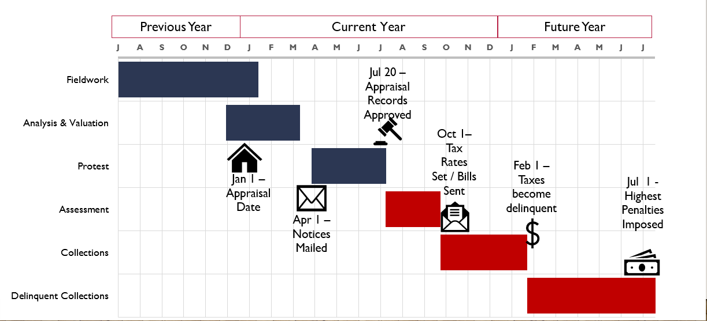

Appraisal District Operations
 | 2016 | 2017 | 2018 | 2019 | 2020
Budget | $4,307,630 | $4,475,530 | $4,651,530 | $5,064,230 | $5,238,693
Market Value | $20,897,453,425 | $22,581,289,680 | $23,435,859,067 | $26,281,008,073 | $29,980,938,519
Accounts
Residential | 105,957 | 104,252 | 106,836 | 107,424 | 107,922
Commercial | 6,266 | 6,315 | 6,352 | 6,501 | 11,839
Business Personal Property | 15,947 | 18,374 | 18,296 | 18,478 | 14769
Land | 26,239 | 26,412 | 26,529 | 27,392 | 34,992
Minerals | 0 | 0 | 0 | 0 | 0
Exempt | 9,214 | 9,393 | 9,571 | 9,568 | 9671
Total | 163,623 | 164,746 | 167,584 | 169,363 | 179,193
Number of Personnel
Budgeted Number of Personnel | 51 | 51 | 51 | 51 | 51
Number of Personnel | 50 | 50 | 49 | 49 | 48
Administration | 4 | 4 | 4 | 4 | 4
Collection & Customer Services | 18 | 18 | 15 | 15 | 14
Mapping / Records Services | 8 | 8 | 8 | 8 | 7
Information Systems | 2 | 2 | 2 | 2 | 3
Appraisal Services | 18 | 18 | 21 | 20 | 20

The Tax Appraisal District of Bell County employs up to 51 employees. TADBC operates 3 offices. The main office is in Belton, with satellite offices at each of the Bell County Killeen and Temple Annex Buildings. The Belton office houses the majority of TADBC’s staff and provides all services to include records, research, appeals processing and collections. The Killeen and Temple offices each provide information, collection, and exemption services.
Thirteen of the staff members have obtained their Registered Professional Appraiser License with the Texas Department of Licensing (TDLR). One staff member has obtained their Registered Tax Collector and Four staff members have obtained their Registered Tax Assessor with TDLR.

Budget
The budget must be prepared and presented each year to the Board of Directors and the taxing entities by June 15th. It must then be approved in a public hearing by the Board of Director’s and sent to the taxing entities. The Tax Appraisal District of Bell County’s budget begins October 1st for each year. The budget outlines goals, objectives, and programs to be accomplished, operating and maintenance expenditures, personnel breakdown with staffing level and salary ranges schedule of capitalized equipment to be purchased.
The adopted budget is then allocated to each taxing unit as a percentage determined by that unit’s levy percentage of the total levies of all taxing entitles.
Financial Statements are audited annually by a Certified Public Accountant in accordance with generally accepted auditing standards. Results of the audit are presented to the Board of Directors.
Tax Year | 2016 | 2017 | 2018 | 2019 | 2020
Budget | $4,307,630 | $4,475,530 | $4,651,530 | $5,064,230 | $5,238,693
% Change | 5.72% | 3.90% | 3.93% | 8.87% | 3.45%

The adopted budget is then allocated to each taxing unit as a percentage determined by that unit’s levy percentage of the total levies of all taxing entitles. Below show the past years’ allocations by taxing entity types.
Budget Allocations | 2016 | 2017 | 2018 | 2019 | 2020
School Districts / ISD | $2,084,833 | $2,170,075 | $2,275,105 | $2,558,365 | $2,649,745
Cities | $982,116 | $1,022,259 | $1,061,509 | $1,120,057 | $1,160,479
County | $797,651 | $830,255 | $857,115 | $901,317 | $933,744
College Districts | $220,267 | $229,270 | $228,780 | $237,916 | $246,475
Water Districts | $10,083 | $10,495 | $27,552 | $29,938 | $48,250
Health / Bioscience District | $12,582 | $13,097 | $11,267 | $11,860 | $12,286
Municipal Utility Districts | $77 | $79 | $2,205 | $4,777 | $4,948

Budget Comparisons

Similar appraisal districts have been compared below to the show the cost per parcel to produce the appraisal roll. This is calculated by dividing the total budget by the total number of parcels. All values are as reported in the 2019 Operations Survey published the Texas Comptroller. Budgets listed below are for all operations of that appraisal district. Only Bell, Midland and Lubbock also conduct assessment and collection operations.

District | Parcels | Budget | Budget / Parcel
Jefferson | 150,010 | $7,216,898 | $48.11
Webb | 149,689 | $5,987,471 | $40.00
Nueces | 214,433 | $8,243,638 | $38.44
Galveston | 194,671 | $6,001,154 | $30.83
Lubbock | 147,155 | $4,500,163 | $30.58
Smith | 177,600 | $4,941,045 | $27.82
Potter/Randall | 145,296 | $4,008,335 | $27.59
Brazos | 136,849 | $3,528,665 | $25.79
Bell | 169,363 | $3,753,330 | $22.16
Midland | 225,750 | $3,546,674 | $15.71

Similar appraisal districts have been compared below to demonstrate appraisal and operating efficiencies based on how much it cost to produce a market value appraisal roll. This is a cost / budget percentage obtained by dividing the market value by each district’s budget. All values are as reported in the 2019 Operations Survey published by the Texas Comptroller. Budgets listed below are for all operations of that appraisal district. Only Bell, Midland and Lubbock also conduct assessment and collection operations.

District | Market Value | Budget | Budget / Parcel
Jefferson | $33,517,642,968 | $7,216,898 | 0.000215
Webb | $29,085,599,022 | $5,987,471 | 0.000205
Smith | $24,382,228,393 | $4,941,045 | 0.000203
Lubbock | $23,025,984,466 | $4,500,163 | 0.000195
Nueces | $43,372,626,740 | $8,243,638 | 0.000190
Potter/Randall | $23,412,814,693 | $4,008,335 | 0.000171
Galveston | $41,397,045,854 | $6,001,154 | 0.000145
Bell | $26,813,253,743 | $3,753,330 | 0.000140
Brazos | $26,113,631,834 | $3,528,665 | 0.000135
Midland | $41,985,868,029 | $3,546,674 | 0.000084

Taxing Entities Served

TADBC serves 39 taxing entities. For all these entities, TADBC provides appraisal services for all parcels within Bell County boundaries. For most of the entities, TADBC also provides assessment and collection services. Out of the 254 counties in Texas, 106 counties have the appraisal districts provide collections services. Since the establishment of the Tax Appraisal District of Bell County, the TADBC has collected taxes for the county and most of the other entities within Bell County.

TAXING ENTITY | Appraise |  | Collect
COUNTY
BELL COUNTY | Y |  | Y
ROAD DISTRICT | Y |  | Y
INDEPENDENT SCHOOL DISTRICTS
ACADEMY ISD | Y |  | Y
BARTLETT ISD | Y |  | Y
BELTON ISD | Y |  | Y
BRUCEVILLE-EDDY ISD | Y
COPPERAS COVE ISD | Y
FLORENCE ISD (Collect only taxes within Bell County) | Y |  | Y
GATESVILLE ISD | Y
HOLLAND ISD | Y |  | Y
KILLEEN ISD | Y |  | Y
LAMPASAS ISD | Y
MOODY ISD | Y
ROGERS ISD | Y |  | Y
ROSEBUD-LOTT ISD | Y
SALADO ISD | Y |  | Y
TEMPLE ISD | Y |  | Y
TROY ISD | Y |  | Y
CITIES
CITY OF BARTLETT | Y |  | Y
CITY OF BELTON | Y |  | Y
CITY OF HARKER HEIGHTS | Y |  | Y
CITY OF HOLLAND | Y |  | Y
CITY OF KILLEEN | Y |  | Y
MORGAN'S POINT RESORT | Y |  | Y
CITY OF NOLANVILLE | Y |  | Y
CITY OF ROGERS | Y |  | Y
VILLAGE OF SALADO | Y |  | Y
CITY OF TEMPLE | Y |  | Y
CITY OF TROY | Y |  | Y
TAXING ENTITY |  | Appraise | Collect
WATER DISTRICTS
CLEARWATER UNDERGROUND WATER CONSERVATION DISTRICT |  | Y | Y
ELM CREEK |  | Y | Y
BELL COUNTY WCID# 3 |  | Y | Y
BELL COUNTY WCID# 6 |  | Y | Y
DONAHOE CREEK |  | Y | Y
COLLEGE DISTRICTS
CENTRAL TEXAS COLLEGE |  | Y | Y
TEMPLE COLLEGE |  | Y | Y
MUNICIPAL UTILITY DISTRICTS
BELL COUNTY MUNICIPAL UTILITY DISTRICT #1 |  | Y | Y
BELL COUNTY MUNICIPAL UTILITY DISTRICT #2 |  | Y | Y
HEALTH & BIOSCIENCE DISTRICT
TEMPLE HEALTH & BIOSCIENCE DISTRICT |  | Y | Y

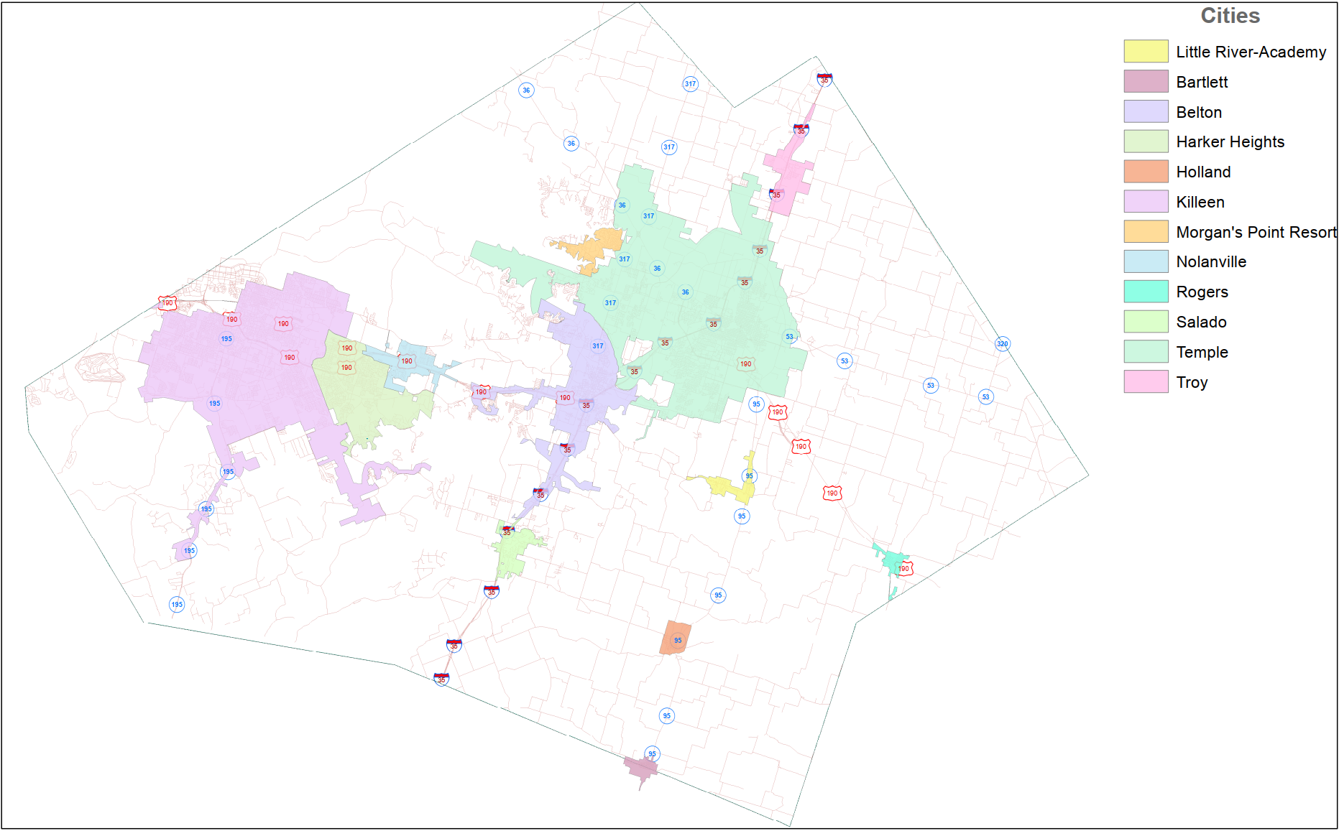
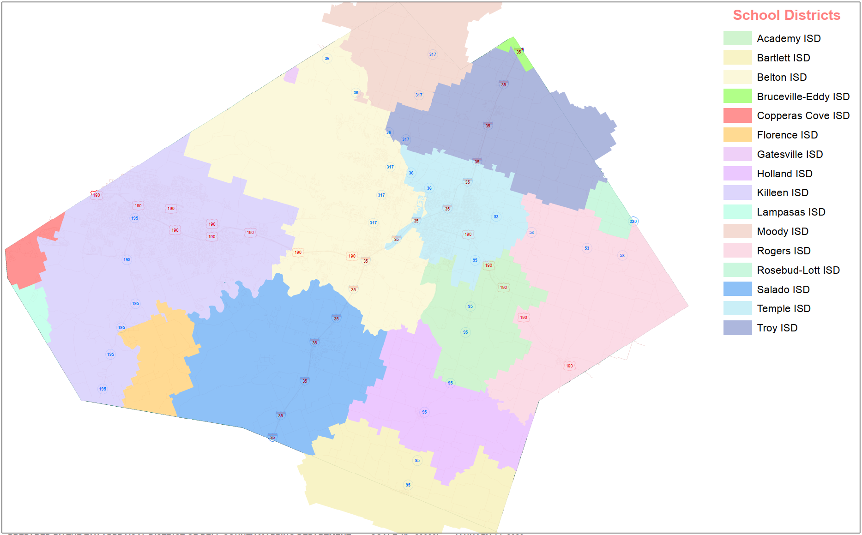

Tax Collection Operations

The Tax Appraisal District of Bell County provides tax collection for 33 of the taxing entities and tax-rate calculation services for 30 of the entities served. These services include:
- Calculation of the effective tax rates, and rollback tax rates
- Required posting of hearings
- Collection and disbursement of all taxes levied
- Applying applicable tax refunds
- Administration of abatements
- Vehicle inventory tax calculation and collection
Tax Statements (bills) are generally sent in October.

January 31st serves as the deadline to pay most taxes, however tax collection services are provided year-round. This includes collecting late taxes (assessed with penalties and interest), quarterly payments, installment payments, and escrowed payments. Certain entities within Bell County have elected to give discounts to taxpayers that pay their taxes in full by certain dates. Currently, these entities provide discounts:
October 31st – 3%
November 30th – 2%
December 31st – 1%
 | 2015 | 2016 | 2017 | 2018 | 2019
Total Tax Levy Collected* | $367,698,406 | $381,324,096 | $407,601,720 | $432,353,985 | $453,150,752
*Includes taxes for entities that TADBC does not collect for based on taxable value of appraisal roll within Bell County boundaries

TAXING ENTITY | 2019 Tax Levy Collected
COUNTY
BELL COUNTY | $79,369,083
ROAD DISTRICT | $5,639,388
INDEPENDENT SCHOOL DISTRICTS
ACADEMY ISD | $6,184,248
BARTLETT ISD | $1,299,370
BELTON ISD | $51,46,521
BRUCEVILLE-EDDY ISD* | $37,429*
COPPERAS COVE ISD* | $1,023,461*
FLORENCE ISD | $861,238
GATESVILLE ISD* | $8,872*
HOLLAND ISD | $1,748,512
KILLEEN ISD | $93,797,590
LAMPASAS ISD* | $126,446*
MOODY ISD* | $612,073*
ROGERS ISD | $2,483,766
ROSEBUD-LOTT ISD* | $117,140*
SALADO ISD | $13,588,421
TEMPLE ISD | $55,996,235
TROY ISD | $5,249,563
CITIES
CITY OF BARTLETT | $242,734
CITY OF BELTON | $8,237,280
CITY OF HARKER HEIGHTS | $12,280,499
CITY OF HOLLAND | $188,220
CITY OF KILLEEN | $47,380,089
MORGAN'S POINT RESORT | $1,851,267
CITY OF NOLANVILLE | $1,249,278
CITY OF ROGERS | $187,835
VILLAGE OF SALADO | $1,160,059
CITY OF TEMPLE | $34,020,734
CITY OF TROY | $714,700

TAXING ENTITY | 2019 Tax Levy Collected
WATER DISTRICTS
CLEARWATER UNDERGROUND WATER CONSERVATION DISTRICT | $708,534
ELM CREEK | $286,659
BELL COUNTY WCID# 3 | $85,147
BELL COUNTY WCID# 6 | $1,732,462
DONAHOE CREEK | $13,203
COLLEGE DISTRICTS
CENTRAL TEXAS COLLEGE | $11,551,715
TEMPLE COLLEGE | $9,991,535
MUNICIPAL UTILITY DISTRICTS
BELL COUNTY MUNICIPAL UTILITY DISTRICT #1 | $593,885
BELL COUNTY MUNICIPAL UTILITY DISTRICT #2 | $28,002
HEALTH & BIOSCIENCE DISTRICT
TEMPLE HEALTH & BIOSCIENCE DISTRICT | $1,057,560
*Includes taxes for entities that TADBC does not collect for based on taxable value of appraisal roll within Bell County boundaries

Exemptions

The homestead exemption is for owner occupied residential properties. The exemption removes a portion of your value from taxation providing a lower tax amount for the homestead property. If you qualify for the Over 65 exemption, there is a property tax “ceiling” that automatically limits school taxes to the amount you paid in the year that you first qualified for the Over 65 exemption. 100 percent Disabled veterans are eligible for 100 percent exemptions for their residence homestead. Documentation from the Department of Veterans Affairs must be submitted indicating 100 percent disability compensation due to a service-connected disability and a rating of 100 percent disabled or a determination of individual unemployability from the Veteran’s Affairs Administration.

TAXING ENTITY | Local Homestead | State Homestead | State Over 65 | State Disabled | Local Over 65 | Local Disabled
COUNTY
BELL COUNTY | $0 |  |  |  | $16,670 | $10,000
ROAD DISTRICT | $0 |  |  |  | $16,670 | $10,000
INDEPENDENT SCHOOL DISTRICTS
ACADEMY ISD |  | $25,000 | $10,000 | $10,000 | $6,000
BARTLETT ISD |  | $25,000 | $10,000 | $10,000
BELTON ISD |  | $25,000 | $10,000 | $10,000
BRUCEVILLE-EDDY ISD |  | $25,000 | $10,000 | $10,000
COPPERAS COVE ISD |  | $25,000 | $10,000 | $10,000
FLORENCE ISD |  | $25,000 | $10,000 | $10,000
GATESVILLE ISD |  | $25,000 | $10,000 | $10,000
HOLLAND ISD |  | $25,000 | $10,000 | $10,000
KILLEEN ISD |  | $25,000 | $10,000 | $10,000
LAMPASAS ISD |  | $25,000 | $10,000 | $10,000
MOODY ISD |  | $25,000 | $10,000 | $10,000
ROGERS ISD |  | $25,000 | $10,000 | $10,000
ROSEBUD-LOTT ISD |  | $25,000 | $10,000 | $10,000
SALADO ISD |  | $25,000 | $10,000 | $10,000 | $3,330
TEMPLE ISD |  | $25,000 | $10,000 | $10,000 | $5,000 | $5,000
TROY ISD |  | $25,000 | $10,000 | $10,000 | FRZ ONLY
CITIES
CITY OF BARTLETT
CITY OF BELTON |  |  |  |  | $10,000 | $10,000
CITY OF HARKER HEIGHTS |  |  |  |  | $10,000
CITY OF HOLLAND
CITY OF KILLEEN |  |  |  |  | $20,000 | FRZ ONLY
MORGAN'S POINT RESORT
CITY OF NOLANVILLE |  |  |  |  | $3,000 | FRZ ONLY
CITY OF ROGERS |  |  |  |  | $5,000 | $5,000
VILLAGE OF SALADO | $5,000 / 20% |  |  |  | $50,000 | $50,000
CITY OF TEMPLE | $5,000 / 20% |  |  |  | $10,000 | $10,000
CITY OF TROY |  |  |  |  | FRZ ONLY | FRZ ONLY

TAXING ENTITY | Local Homestead | State Homestead | State Over 65 | State Disabled | Local Over 65 | Local Disabled
WATER DISTRICTS
CLEARWATER UNDERGROUND WATER CONSERVATION DISTRICT |  |  |  |  | $5,000
ELM CREEK |  |  |  |  | $5,000
BELL COUNTY WCID# 3
BELL COUNTY WCID# 6
DONAHOE CREEK |  |  |  |  | $3,000
COLLEGE DISTRICTS
CENTRAL TEXAS COLLEGE |  |  |  |  | $15,000 | FRZ ONLY
TEMPLE COLLEGE | $5,000 / 20% |  |  |  | $10,000 | FRZ ONLY
MUNICIPAL UTILITY DISTRICTS
BELL COUNTY MUNICIPAL UTILITY DISTRICT #1
BELL COUNTY MUNICIPAL UTILITY DISTRICT #2
HEALTH & BIOSCIENCE DISTRICT
TEMPLE HEALTH & BIOSCIENCE DISTRICT

In 2020, the Tax Appraisal District of Bell County processed 9,582 exemption applications. Below is a breakdown of the amounts and types of each exemption processed.
- Homestead Exemptions – 4,520
- Over 65 Exemptions – 1,936
- Disabled Person Exemptions – 169
- Disabled Veteran Status 1-4 Exemptions – 1,630
- Disable Veteran Homestead – 1,285
- Total (non-profit) exemptions – 42

Non-profit organizations that are eligible for property tax exemptions include but are not limited to certain charitable organizations, youth development, organizations, religious organizations, non-profit private schools, charitable hospitals, cemeteries, and veterans’ organizations.

Taxing Entity Tax Rates

TAXING ENTITY | Total Tax Rate
COUNTY
BELL COUNTY | $0.3968
ROAD DISTRICT | $0.0285
INDEPENDENT SCHOOL DISTRICTS
ACADEMY ISD | $1.1648
BARTLETT ISD | $1.0944
BELTON ISD | $1.3651
BRUCEVILLE-EDDY ISD | $1.1855
COPPERAS COVE ISD | $1.12865
FLORENCE ISD | $1.2339
GATESVILLE ISD | $1.1645
HOLLAND ISD | $1.2041
KILLEEN ISD | $1.0895
LAMPASAS ISD | $1.3147
MOODY ISD | $1.2196
ROGERS ISD | $1.2069
ROSEBUD-LOTT ISD | $1.1351
SALADO ISD | $1.3747
TEMPLE ISD | $1.2838
TROY ISD | $1.2434
CITIES
CITY OF BARTLETT | $0.4258
CITY OF BELTON | $0.6300
CITY OF HARKER HEIGHTS | $0.6770
CITY OF HOLLAND | $0.43864
CITY OF KILLEEN | $0.7330
MORGAN'S POINT RESORT | $0.5958
CITY OF NOLANVILLE | $0.5303
CITY OF ROGERS | $0.7225
VILLAGE OF SALADO | $0.5339
CITY OF TEMPLE | $0.6525
CITY OF TROY | $0.5453

TAXING ENTITY | Total Tax Rate
WATER DISTRICTS
CLEARWATER UNDERGROUND WATER CONSERVATION DISTRICT | $0.003272
ELM CREEK | $0.0327
BELL COUNTY WCID# 3 | $0.0378
BELL COUNTY WCID# 6 | $0.0300
DONAHOE CREEK | $0.0200
COLLEGE DISTRICTS
CENTRAL TEXAS COLLEGE | $0.1218
TEMPLE COLLEGE | $0.1837
MUNICIPAL UTILITY DISTRICTS
BELL COUNTY MUNICIPAL UTILITY DISTRICT #1 | $0.8500
BELL COUNTY MUNICIPAL UTILITY DISTRICT #2 | $0.9500
HEALTH & BIOSCIENCE DISTRICT
TEMPLE HEALTH & BIOSCIENCE DISTRICT | $0.0174

Taxing Entity 2020 Certified Values

TAXING ENTITY | Appraisal Roll Market Value | Appraisal Roll Net Taxable Value
COUNTY
BELL COUNTY | $30,138,518,164 | $22,393,254,246
ROAD DISTRICT | $30,138,518,164 | $22,696,012,146
INDEPENDENT SCHOOL DISTRICTS
ACADEMY ISD | $883,736,382 | $596,896,081
BARTLETT ISD | $205,521,745 | $56,316,283
BELTON ISD | $6,011,134,473 | $4,280,790,995
BRUCEVILLE-EDDY ISD | $4,308,985 | $3,185,152
COPPERAS COVE ISD | $167,919,124 | $106,131,428
FLORENCE ISD | $179,089,760 | $80,414,942
GATESVILLE ISD | $3,535,487 | $924,347
HOLLAND ISD | $385,575,139 | $149,964,984
KILLEEN ISD | $12,737,048,779 | $9,379,393,448
LAMPASAS ISD | $25,162,349 | $11,181,104
MOODY ISD | $178,974,717 | $58,587,199
ROGERS ISD | $477,573,065 | $210,268,296
ROSEBUD-LOTT ISD | $27,441,542 | $12,195,085
SALADO ISD | $1,951,795,351 | $1,192,472,734
TEMPLE ISD | $6,047,794,064 | $4,802,783,719
TROY ISD | $851,854,375 | $516,755,735
CITIES
CITY OF BARTLETT | $31,012,682 | $22,611,769
CITY OF BELTON | $2,086,397,699 | $1,465,089,774
CITY OF HARKER HEIGHTS | $2,583,390,980 | $2,036,994,787
CITY OF HOLLAND | $64,089,484 | $48,986,706
CITY OF KILLEEN | $8,825,469,017 | $7,065,784,289
MORGAN'S POINT RESORT | $385,732,571 | $344,269,229
CITY OF NOLANVILLE | $372,633,092 | $286,296,154
CITY OF ROGERS | $35,693,548 | $28,889,455
VILLAGE OF SALADO | $424,889,705 | $283,659,439
CITY OF TEMPLE | $8,210,181,541 | $6,136,059,427
CITY OF TROY | $187,608,418 | $158,671,253

TAXING ENTITY | Market Value | Net Taxable
WATER DISTRICTS
CLEARWATER UNDERGROUND WATER CONSERVATION DISTRICT | $30,138,518,164 | $22,859,932,670
ELM CREEK | $1,573,777,661 | $1,044,692,773
BELL COUNTY WCID# 3 | $337,394,430 | $255,166,311
BELL COUNTY WCID# 6 | $8,093,415,008 | $6,540,171,295
DONAHOE CREEK | $252,952,396 | $72,775,670
COLLEGE DISTRICTS
CENTRAL TEXAS COLLEGE | $12,915,819,678 | $10,067,297,469
TEMPLE COLLEGE | $8,288,755,288 | $6,168,894,788
MUNICIPAL UTILITY DISTRICTS
BELL COUNTY MUNICIPAL UTILITY DISTRICT #1 | $136,472,662 | $113,039,713
BELL COUNTY MUNICIPAL UTILITY DISTRICT #2 | $4,874,063 | $4,874,063
HEALTH & BIOSCIENCE DISTRICT
TEMPLE HEALTH & BIOSCIENCE DISTRICT | $8,211,765,317 | $6,911,385,880

Top 10 Taxpayers

Taxpayer | Market Value | Taxable Value
ONCOR ELECTRIC DELIVERY CO LLC | $332,504,996 | $332,504,996
WAL-MART REAL ESTATE BUSINESS TRUST | $117,602,939 | $117,602,939
WILSONART LLC | $116,596,465 | $114,891,521
MCLANE COMPANY INC | $106,020,984 | $104,690,222
TEMPLE GENERATION I LLC | $239,137,567 | $97,708,367
BURLINGTON NORTHERN SANTA FE RAILWAY CO | $87,191,280 | $87,191,280
PANDA TEMPLE POWER II LLC | $273,841,810 | $82,139,795
H E BUTT GROCERY | $122,578,305 | $76,367,331
DRP MARKET HEIGHTS PROPERTY OWNER LLC | $62,933,548 | $62,933,548
PACTIV LLC | $65,827,959 | $62,701,062

Property Values By State Property Categories

State Code | State Code Description | Property Count | New Value | Market Value | Taxable Value
A | Single Family Residence | 97,271 | $468,957,093 | $15,512,036,827 | $12,790,884,188
B | Multi-Family Residence | 6,287 | $49,962,806 | $1,842,235,434 | $1,832,639,718
C1 | Vacant Lots & Land Tracts | 16,174 | $30,182 | $452,792,290 | $451,103,454
D1 | Qualified Open-Space Land | 9,712 | $0 | $2,121,795,664 | $58,623,423
D2 | Improvements on Qualified Open-Space Land | 1,394 | $1,902,111 | $20,400,245 | $20,210,432
E | Rural Land | 7,712 | $29,695,048 | $1,369,850,733 | $1,222,191,930
F1 | Commercial Real | 5,343 | $39,639,613 | $2,599,180,873 | $2,598,370,086
F2 | Industrial & Manufacturing Real | 209 | $29,659,564 | $816,885,413 | $425,394,267
G1 | Oil & Gas | 0 | $0 | $0 | $0
J1 | Water Systems | 7 | $0 | $352,570 | $352,570
J2 | Gas Distribution Systems | 22 | $0 | $32,702,901 | $32,702,901
J3 | Electric Company | 117 | $0 | $348,106,230 | $348,106,230
J4 | Telephone Company | 51 | $0 | $39,029,064 | $39,029,064
J5 | Railroad | 46 | $0 | $133,928,000 | $133,928,000
J6 | Pipeline Company | 205 | $0 | $25,850,637 | $22,529,657
J7 | Cable Television Company | 24 | $0 | $36,674,223 | $36,674,223
J8 | Other Type of Utility | 0 | $0 | $0 | $0
J9 | Railroad Rolling Stock | 3 |  |  | $20,508,628
L1 | Commercial Personal Property | 13,402 | $2,369,761 | $919,215,614 | $919,137,576
L2 | Industrial & Manufacturing Personal Property | 706 | $0 | $834,988,939 | $824,598,802
M1 | Mobile Homes, Personal Property | 5,012 | $2,772,154 | $41,859,473 | $37,215,121
O | Residential Inventory | 5,639 | $118,369,746 | $295,798,050 | $288,047,788
S | Special Inventory | 189 | $0 | $101,152,680 | $101,152,680
X | Total Exempt | 9,671 | $13,728,113 | $2,436,102,659 | $0
 | Totals | 179,196* | $757,086,191 | $29,980,938,519 | $22,203,400,738

*Count is based on number of properties with state code, if property has multiple state codes, property will be duplicated in property account.

County Growth

Commercial Growth
In Bell County in 2020, many new commercial improvements were made to include:
- 17 Industrial / Service
- 13 Office
- 33 Entertainment / Retail
- 10 Apartment / Hotel / Mini Storage

Property Value Appeals

In accordance with Texas Property Tax Code, Section 41.44 a property owner and / or authorized tax agent may file an appeal with the Appraisal Review Board (ARB) having authority to hear the matter protested.
Timing of the COVID-19 pandemic and subsequent business shutdowns did not allow for the TADBC to have an inquiry period in 2020. This also caused delays in delivery of appraisal notices as most were mailed on May 14, 2020.
The ARB is composed of members appointed by the county administrative judge and do not work for the appraisal district. They are appointed to arbitrate disputes in values between TADBC and property owners. All appeals that that are not resolved informally with TADBC, are decided by the ARB.
1n 2020, 19,708 accounts were appealed. 6,572 accounts were protested online. 2,585 accounts received a formal hearing with the Appraisal Review Board.

Texas State Comptroller Property Tax Assistance Division Studies

The Property Tax Assistance Division (PTAD) performs reviews of all appraisal districts in the state. Alternating each year, PTAD will perform a Property Value Study (PVS) and a Methods and Assistance Program (MAP) review. PTAD performs the PVS on odd years for TADBC and the MAP review on even years. For each of the reviews, the results are not typically published until the January following the review.
During the PVS, PTAD uses measurements to determine the median level of appraisal, and the accuracy of the CAD’s appraisals. PTAD most recently performed a PVS in 2019 for Bell County. Below are the results.
Category | Number of Ratios ** | 2019 CAD Rept Appraised Value | Median Level of Appr | Coefficient of Dispersion | % Ratios w/in (+/-) 10% of Median | % Ratios w/in (+/-) 25% of Median | Price-Related Differential
A. SINGLE-FAMILY RESIDENCES | 1916 | 13,927,716,726 | 1.00 | 9.30 | 71.06 | 92.44 | 1.01
B. MULTI-FAMILY RESIDENCES | 210 | 1,563,628,667 | * | * | * | * | *
C1. VACANT LOTS | 0 | 425,885,075 | * | * | * | * | *
C2. COLONIA LOTS | 0 | 0 | * | * | * | * | *
D2. FARM/RANCH IMP | 0 | 20,229,040 | * | * | * | * | *
E. RURAL-NON-QUAL | 175 | 1,194,918,013 | 0.99 | 18.98 | 40.58 | 74.37 | 1.06
F1. COMMERCIAL REAL | 148 | 2,229,336,402 | 0.85 | 20.68 | 26.07 | 65.03 | 1.02
F2. INDUSTRIAL REAL | 0 | 763,945,719 | * | * | * | * | *
G. OIL, GAS, MINERALS | 0 | 0 | * | * | * | * | *
J. UTILITIES | 20 | 550,458,870 | 0.89 | 31.63 | 46.35 | 51.35 | 0.72
L1. COMMERCIAL PERSONAL | 92 | 862,902,288 | * | * | * | * | *
L2. INDUSTRIAL PERSONAL | 0 | 739,170,128 | * | * | * | * | *
M. OTHER PERSONAL | 0 | 41,059,986 | * | * | * | * | *
O. RESIDENTIAL INVENTORY | 0 | 205,411,465 | * | * | * | * | *
S. SPECIAL INVENTORY | 0 | 95,931,582 | * | * | * | * | *
OVERALL | 2561 | 22,620,593,961 | 1.00 | 10.57 | 67.20 | 89.33 | 1.06
*Not Calculated – Need a minimum of 5 ratios from either (A) categories representing at least 25% of total CAD category value or (B) 5 ISDs or half the ISDs in the CAD, whichever is less.
**Statistical measures may not be reliable when the sample is small.

The MAP review determines whether appraisal districts are meeting requirements. PTAD most recently performed a MAP review of TADBC in 2018. Below are the results.
This review is conducted in accordance with Tax Code Section 5.102(a) and related to Comptroller Rule 9.301. The Comptroller is required by statue to review appraisal district governance, taxpayer assistance, operating procedures, and appraisal standards.
Mandatory Requirements | PASS/FAIL
Does the appraisal district have up-to-date appraisal maps? | PASS
Is the implementations of the appraisal district’s most recent reappraisal plan current? | PASS
Does the appraisal district comply with its written procedures for appraisal? | PASS
Are the values reproducible using the appraisal district’s written procedures and appraisal records? | PASS

Appraisal District Activities | RATING
Governance | Meets All
Taxpayer Assistance | Meets All
Operating Procedures | Meets All
Appraisal Standards, Procedures and Methodology | Meets

Appraisal District Ratings:
Meets All – The total point score is 100
Meets – The total point score ranges from 90 to less than 100
Needs Some Improvement – The total point score ranges from 85 to less than 90
Needs Significant Improvement – The total point score ranges from 75 to less than 85
Unsatisfactory – The total point score is less than 75

Legislative Changes

The 2019, 86th Texas Legislature produced many pieces of legislation which affect the operation of appraisal districts as well as taxpayer exemptions and rights. Some of the changes are listed below.
HB 639 amends Sec. 23.51(1) to require that land used principally as an ecological laboratory must have been used principally in that manner by the college or university for five of the preceding seven years to qualify for agricultural appraisal.
HB 1060 states that the ARB will deliver board orders by certified mail if the owner requests this on their protest form. The ARB may require the owner to pay the fees. Board orders may be delivered by email if the property owner requests it on their protest form and provides an email address for delivery.
HB 2241 relates to the entitlement of a person who is disabled and elderly to receive a disabled residence homestead exemption from ad valorem taxation from one taxing unit and an elderly exemption from another taxing unit.
HB 1313 states that the chief appraiser may not raise the value of a property that was the subject of an ARB hearing or lawsuit without clear and convincing evidence. Also, it makes all homestead exemptions passable to a surviving spouse.
HB 2179 removes the “clear and convincing” language for removal of an ARB member for bias and allows tax agents or owners to communicate directly with the administrative district judge for purposes of having an ARB member removed.
HB 1802 changes the deadline for filing a request for binding arbitration of certain appraisal review board orders from 45 days to 60 days.
HB 1743 states that the change of use penalty for ag land will be for the three years prior instead of five with an interest rate of five percent instead of seven.
HB 2446 adds volunteer or paid firefighters and EMS personnel to the list of people who can choose to have their address confidential.
SB 443 allows for the property owner to continue to receive their HS for up to five years if their home is determined to be uninhabitable/unusable and in a disaster area that has been declared by the governor.
SB 58 exempts lease vehicles that are leased to the state, local government or 501(c)(3) organization and used exclusively for religious/educational/charitable purposes. Allows the lessor to keep an electronic copy of the form instead of the original form.
SB 494 changes the amount of time from 2 hours to 1 hour for when a notice of public meeting due to an emergency or urgent public necessity must be posted.
SB 2 provides that information requested under 41.461 may be submitted electronically. Owners of residential property that is occupied as their principal residence may request to have all communication from a CAD sent electronically and the request will remain in effect until revoked. Deletes the requirement for estimated taxes on Notices of Appraised Value. Hearings may be rescheduled by owners and agents for failure to comply with 41.461. Information not provided under 41.461 may not be used in an ARB hearing as evidence or testimony. This does not apply to the rebuttal of taxpayer or agent evidence. The ARB must schedule a hearing on a protest filed by a property owner who is 65 years of age or older, disabled, or a military service member before scheduling agent protests.

2020 Certified Totals

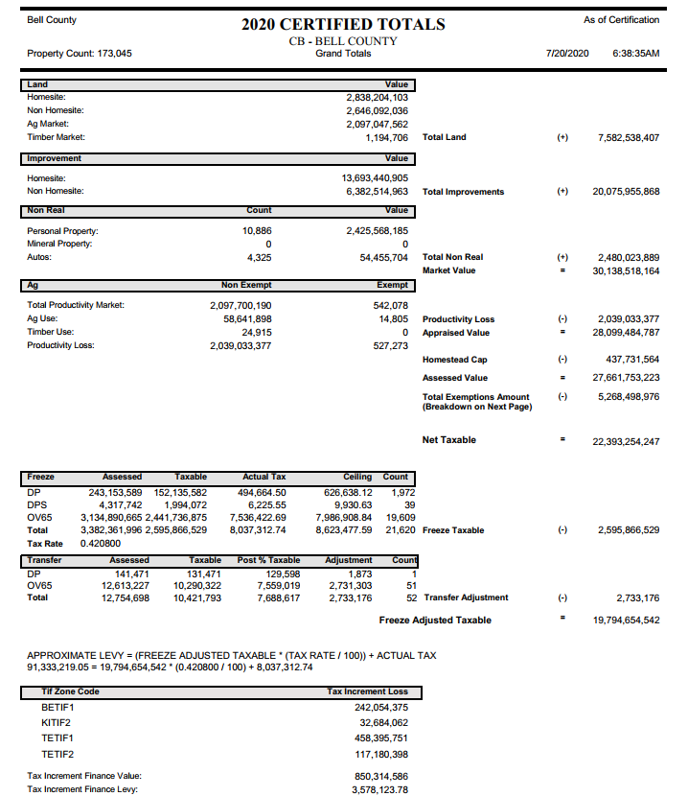

Contact Us

Office Locations
Main Office
Belton
411 E. Central Avenue
Belton, TX 76513

Satellite Offices
Killeen
301 Priest Dr.
Killeen, TX 76541

Temple
205 E. Central Avenue
Temple, TX 76501

Phone
(254) 939-5841
info@bellcad.org
www.bellcad.org

Business Hours
Monday – Friday 8:00 AM – 4:45 PM

